Jenkins Tutorial – Flask CI/CD Project [Webhook Explained]
🔗 What is a Webhook?
A webhook is a way for one system to send real-time data to another system as soon as an event occurs.
It’s like an automatic “notification” that carries data about an event.
In simple terms:
- GitHub is the source system — it detects an event like a code push.
- Jenkins is the destination system — it listens for that event.
When you push code to GitHub, the webhook sends an HTTP POST request to Jenkins with details about the event (like branch, commit, etc.).
Jenkins receives that payload and automatically triggers a build or deployment.
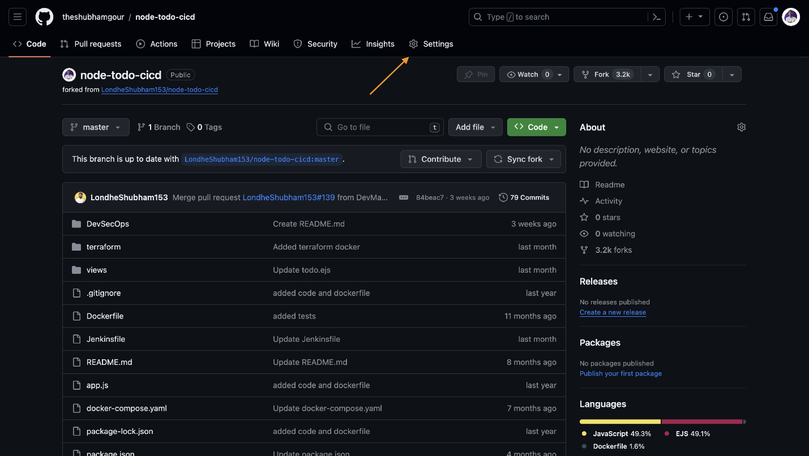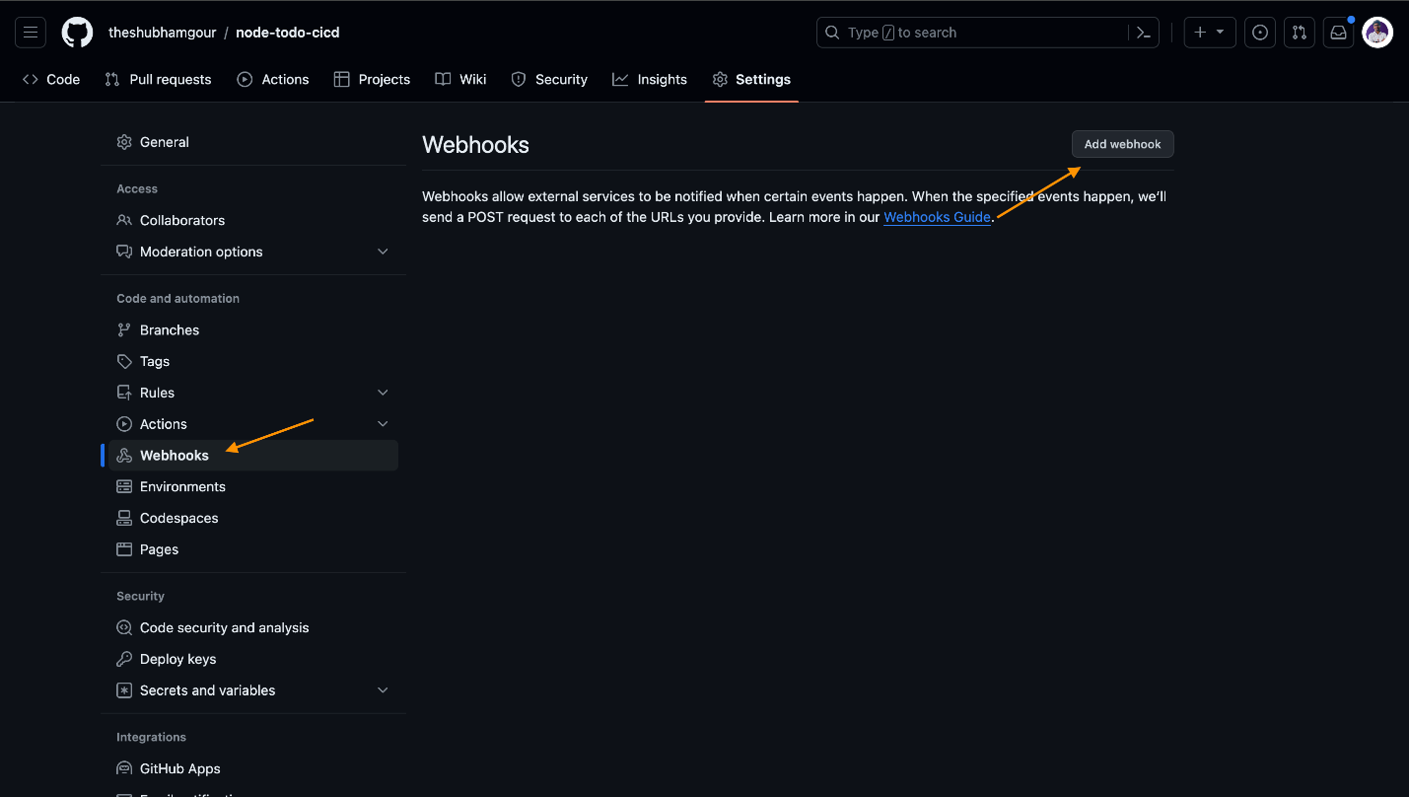
Example: When you push a commit to your Flask project’s GitHub repo, Jenkins (through the webhook URL) detects it and automatically starts the pipeline — building a Docker image, running tests, or deploying your app.
This enables Continuous Integration (CI) and Continuous Deployment (CD) without manual intervention.

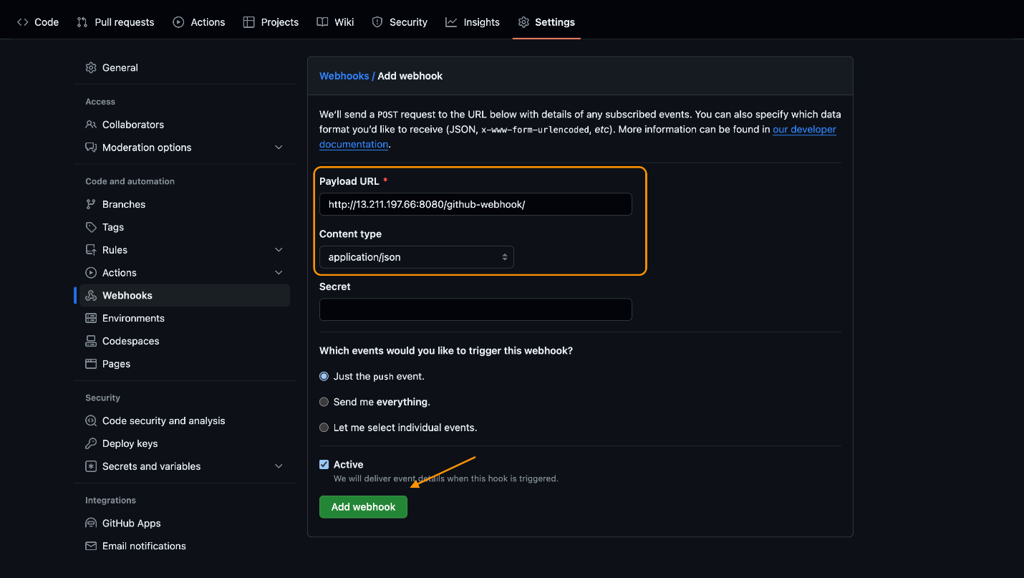
Webhook URL format:
<JENKINS_URL>/github-webhook/
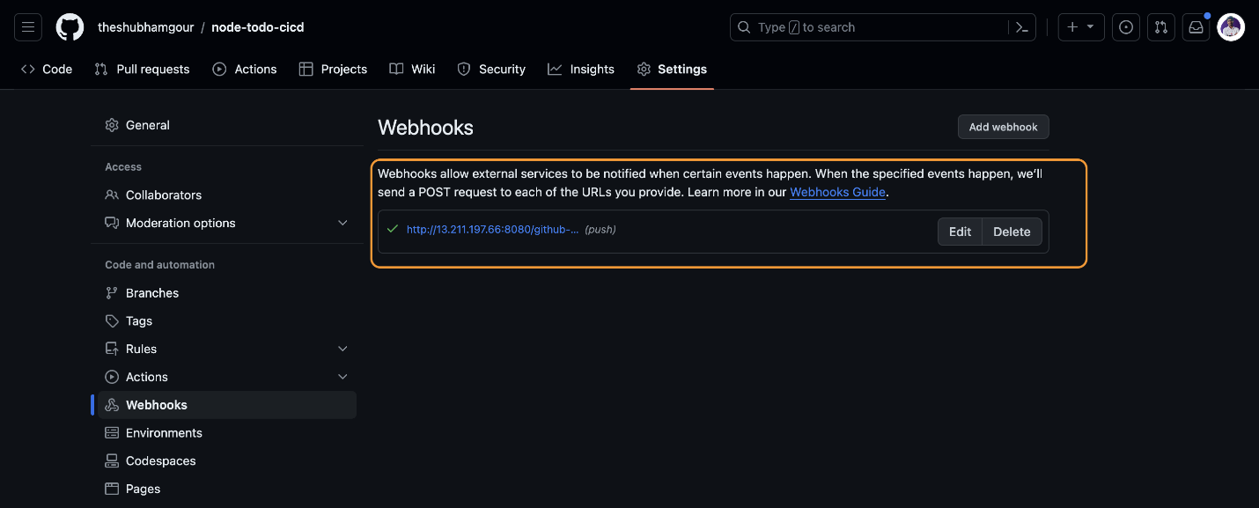
- The Jenkins server must be accessible from the internet (public IP or ngrok).
- GitHub sends POST requests to this URL whenever configured events (like push or PR) occur.
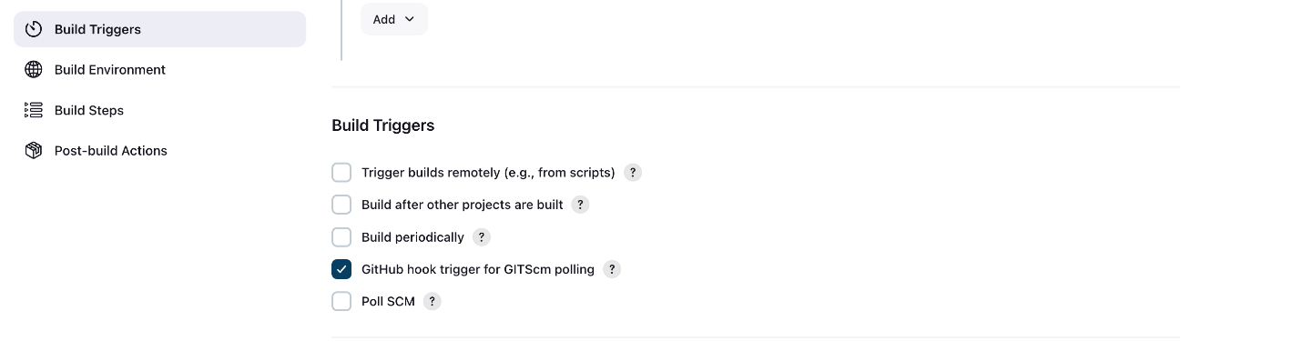

In summary:
Webhooks make Jenkins react automatically to GitHub changes — enabling seamless automation in DevOps pipelines.

